Question 1

Which is the best description of the **SELECT** statement in SQL? (Note, this is not referring to the **SELECT** list.)

The only statement for creating query results

Question 2

Which of the following can be achieved using a **SELECT** statement with Hive or Impala? Check all that apply.

Listing all the data in a table

Displaying the output of an expression

Displaying the data in a table using a specific order for the columns

Displaying specific columns in a table

Question 3

The **customers** table in the **default** database has columns **cust_id**, **name**, and **country** (all string types). Which of the following are valid **SELECT** statements? Check all that apply.

SELECT * FROM customers;

SELECT name, cust_id FROM customers;

SELECT 'Brendon';

Question 4

This **SELECT** statement returns one result. What is the result?

13

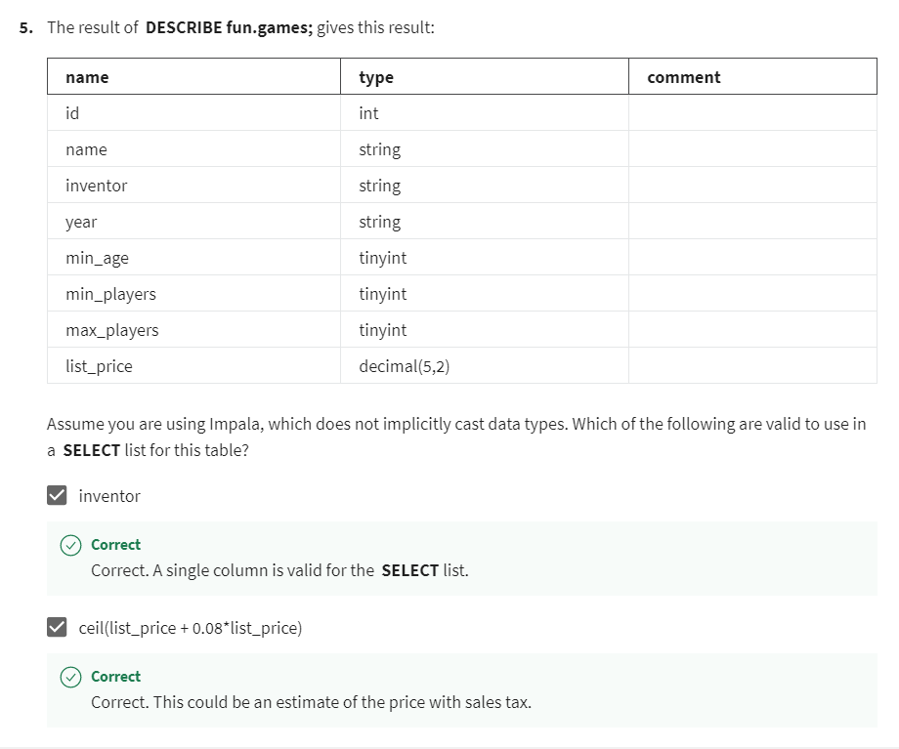

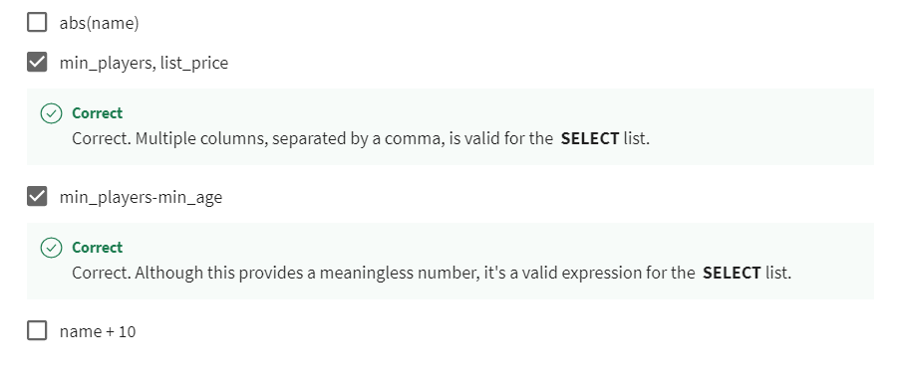

Question 6

Consider this query:

**SELECT game, shop, price, round(0.08*price,2) AS tax FROM fun.inventory;**

Which are the correct column names in the header of the result set for this query?

game, shop, price, _c4, AS, tax

Question 7

This **SELECT** statement returns one result. What is the result?

**SELECT floor(5 - 6.5);**

-2

Question 8

Suppose you want to calculate when each game in the fun.games table celebrated its 10th anniversary. (For information about this table, see the result of the **DESCRIBE** statement in Problem 5 above.) You might try the following query, but using Impala, it will cause an error:

**SELECT year + 10 FROM fun.games;**

Which of the following would correct the error and make the calculation correctly? Check all that apply

.

SELECT cast(year AS INT) + 10 FROM fun.games;

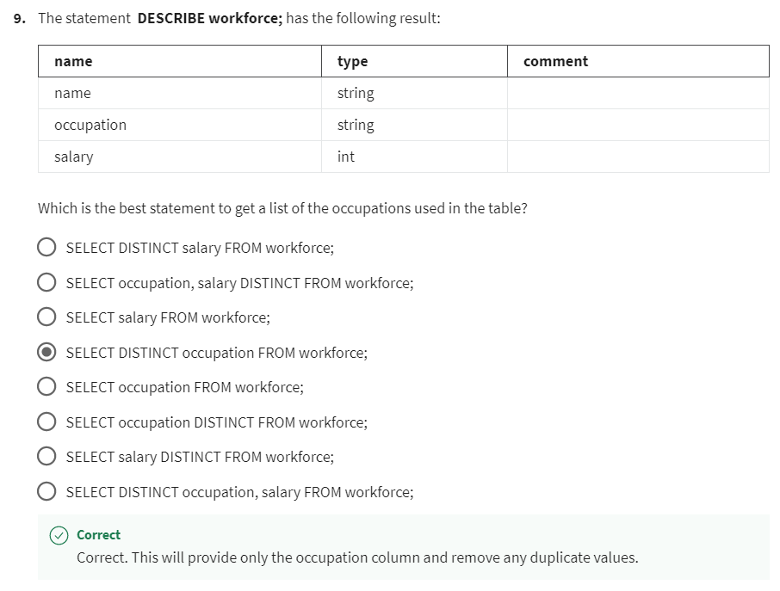

Question 10

You are working in the **default** database and want to list all the data in the **crayons** table, which is in the **wax** database. Which of the following allow you to do that? Check all that apply.

Change the current database to **wax** and run **SELECT * FROM crayons;**

Run **SELECT * FROM wax.crayons;**

Question 11

Which of the following are true of keywords (such as **SELECT** and **FROM**) and identifiers (such as names of tables and columns) in Hive and Impala? Check all that apply.

Keywords are always case-insensitive

By convention, keywords are often shown uppercase